**PUSH BUTTON COUNTER**

**1. Introduction**

**A Push Button Counter with Temperature Display is a basic embedded systems project that counts how many times a button is pressed and displays this count on an LCD. Additionally, it measures the real-time temperature using an analog temperature sensor (TMP36 or LM35) and displays that on the same screen. This type of setup demonstrates how digital and analog inputs can be integrated into a single Arduino-based system, making it a useful project for learning input handling, sensor interfacing, and output display.**

**2. Design and Methodology**

**A digital input from a push button and an analog input from a temperature sensor. Each time the button is pressed, the counter increases and the new value is displayed on a 16x2 LCD. Simultaneously, the TMP36 sensor reads the ambient temperature, converts the analog voltage to a temperature value in Celsius, and displays it on the same LCD. A small delay is used to debounce the button and prevent multiple counts from a single press. This design clearly demonstrates the basic principles of embedded systems: reading inputs, processing data, and showing output.**

**3.components Required**

1. Arduino Uno – 1
2. Push Button – 1
3. LM35 Temperature Sensor – 1
4. 16x2 LCD Display – 1
5. Potentiometer (250kΩ) – 1 *(for LCD contrast control)*
6. Resistor – 220Ω – 1 *(for LCD backlight)*
7. Resistor – 10kΩ – 1 *(pull-down for button)*
8. Resistor – 1kΩ – 1 *(for LED)*
9. LED (Red) – 1
10. Breadboard – 2
11. Jumper Wires – as required

12.USB Cable / Power Supply – 1 *(to power the Arduino)*

**4.Circuit Design**

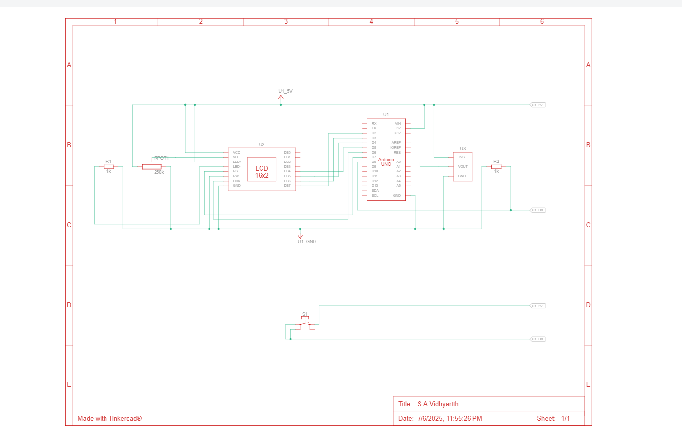

**5.Code**

#include <LiquidCrystal.h>

LiquidCrystal lcd(7, 6, 5, 4, 3, 2);

const int sensor = A0;

const int buttonPin = 8;

int count = 0;

int lastButtonState = 0;

void setup() {

pinMode(buttonPin, INPUT);

lcd.begin(16, 2);

lcd.print("Starting...");

delay(1000);

lcd.clear();

}

void loop() {

int buttonState = digitalRead(buttonPin);

if (buttonState == HIGH && lastButtonState == LOW) {

count++;

if (count > 9) count = 0;

}

lastButtonState = buttonState;

float voltage = analogRead(sensor) * (5.0 / 1023.0);

float temperatureC = (voltage - 0.5) * 100.0;

lcd.clear();

lcd.setCursor(0, 0);

lcd.print("Count: ");

lcd.print(count);

lcd.setCursor(0, 1);

lcd.print("Temp: ");

lcd.print(temperatureC, 1);

lcd.print(" C");

delay(300);

}

**6. Output Demonstration**

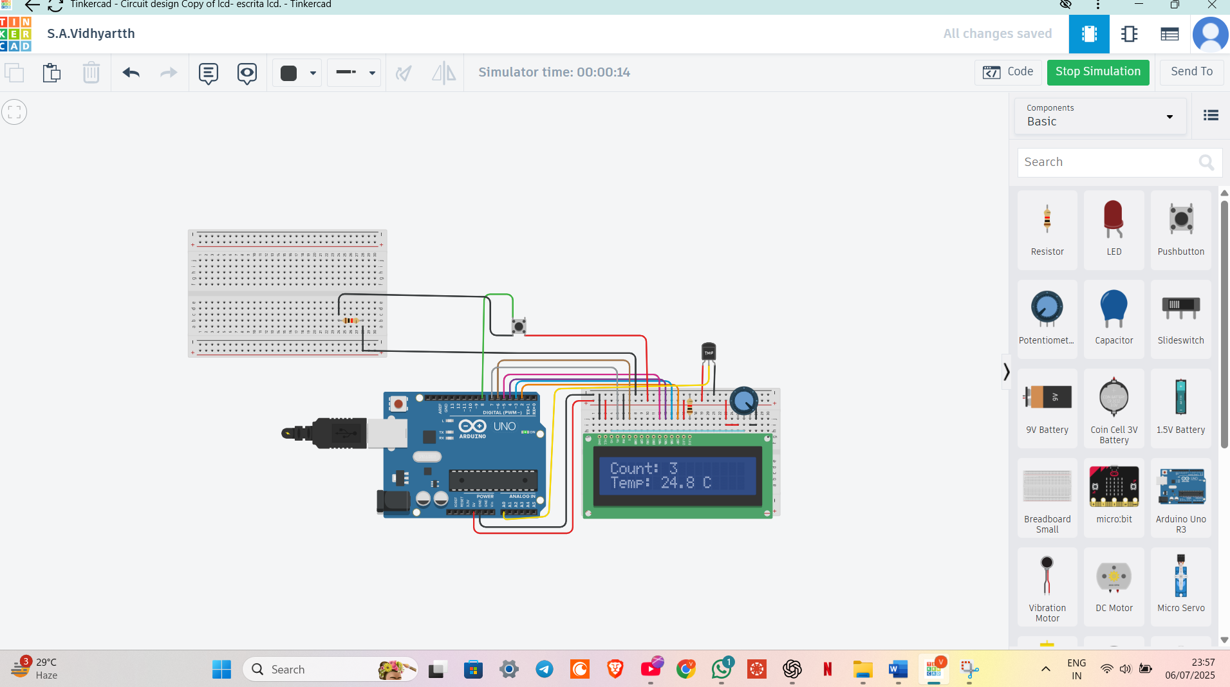

**7.Conlusion**

This project combines a push button and a temperature sensor to count presses and display real-time temperature on an LCD. It shows how digital input the button and analog input the sensor can work together in an Arduino-based system. This setup is simple, effective, and useful for basic embedded system applications.